The Final Report
Team name: ProTeam
Jueun Park, Jihee Kang, Minjea Lee, Pyeonghwa Jang, Soyoung Kim
Project title
Protein Sequence Encoding and Deep Learning-based EC Number Prediction
: A Comparative Study of CNN and Transformer Models
- Analyzing the impact of various protein sequence encoding methods (one-hot, k-mer, token) on EC number prediction
- Comparing the performance of deep learning architectures, CNN and Transformer, to explore the most effective approach
Project significance
The functional classification and comparison of enzymes are essential processes in the fields of biochemistry, molecular biology, and bioinformatics. The Enzyme Commission (EC) number system standardizes enzyme classification based on their catalytic reactions using a four-level hierarchical structure (x.y.z.w), enabling systematic analysis of the functional similarity between enzymes. The more identical the leading digits of the EC numbers, the closer the functional relationship between the respective enzymes.
- The Need for Hierarchical Evaluation
In enzyme function prediction, considering the hierarchical structure of EC numbers allows for recognizing predictions as partially correct when the higher levels match, even if there is not a perfect match. This approach helps reduce information loss that may occur with simple binary evaluation and provides results that more accurately reflect biological significance.
- Significance of the Project Strategy
In this project, the evaluation criterion was set to consider similarity up to the second digit of the EC number, fixing the first digit. Through this approach, functional proximity between enzymes could be reflected in the assessment, capturing the complexity of actual biological phenomena more effectively—even when predictions were not perfectly matched.
Notably, this project was scientifically grounded by referencing the functional similarity measurement methodology proposed by Lord et al. (2003), thereby supporting the necessity and validity of hierarchical evaluation based on enzyme classification.
Literature survey
This project aims to compare the predictive performance of different deep learning models—CNN and Transformer—based on various protein sequence encoding methods (one-hot, k-mer, and tokenization). The experiment design and benchmark model selection were informed by recent papers on protein function prediction and widely used open-source implementations.
1. K-mer Processing Benchmark Model: DNABERT
- The paper “DNABERT” proposed a method that divides DNA sequences into k-mers and treats each k-mer as a token. These k-mers are fed into the input layer of the Transformer model, enabling it to effectively learn semantic and structural patterns within the sequences. Inspired by this idea, we adopted k-mer processing as one of the encoding strategies in our project.
2. CNN Benchmark Model: ECPICK
- “ECPICK (datax-lab, 2023)” is an open-source framework that utilizes one-hot encoding and a 2D CNN architecture to predict enzyme EC numbers from protein sequences. By benchmarking the architecture and training strategy of ECPICK, we designed our own CNN implementation, using a 1D CNN model as the baseline for experimental comparison.
3. Transformer Benchmark Model: Vision Transformer
- The paper “An Image is Worth 16x16 Words: Transformers for Image Recognition at Scale” demonstrated that Transformer architectures, which were originally used primarily in natural language processing, can be directly applied to image recognition tasks. This approach achieved high classification performance. Based on the ideas presented in this paper, we implemented a Transformer model and directly compared its performance with that of the CNN.
Methods
1. Hypothesis
Different protein sequence encoding methods—such as one-hot, k-mer, and tokenization—are expected to have varying effects on the performance of deep learning models (CNN and Transformer) in predicting Enzyme Commission (EC) numbers.
2. Experimental Strategy
(1) EC number:
- To obtain efficient and reliable results within the one-month project period, we limited the classification task to the second level of EC numbers.
- To further narrow the scope of the dataset, we restricted the first-level category to class 1 only.
- EC numbers with fewer than 10 instances were removed due to sparsity.
- To ensure fair comparison, we applied consistent preprocessing and input formatting across all experiments.
(2) Amino acid sequence
- All protein sequences were standardized to a fixed length of 512, based on an average sequence length of 403.
- Sequences shorter than 512 were padded with special tokens.
The vocabulary included 20 standard amino acids along with special characters (PAD, X), resulting in a total of 22 unique sequence tokens.
  - A PAD token was used to unify variable sequence lengths
  - An X token was added to represent unknown or ambiguous amino acids.

3. Experimental Design
(1) Table: Overview of Encoding Methods
Encoding Method | Processing Description | Expected Model Compatibility
one-hot | - Based on ECPICK’s preprocessing code  - Each amino acid is converted into a 22-dimensional one-hot vector | Performs well with CNN
k-mer | - Adapted from the DNABERT paper  - Split and index the sequence into lengths of k | Performs well with Transformer
token | - A simplified approach compared to k-mer  - Each amino acid is assigned an integer index | Can be used with CNN or Transformer (with embedding)
Note: Both k-mer and token-based inputs are passed through an embedding layer to help the model learn sequence-level patterns effectively.
(2) CNN Model Design
The CNN model implemented in this project was designed as a 1D convolutional neural network that supports all three encoding methods: one-hot, k-mer, and token. The model architecture and behavior are described below.
Input Format | - One-hot: 2D array of shape (batch, sequence length, amino acid types)  - Token / k-mer: 1D index sequence of shape (batch, sequence length) with embedding
Conv1D | Conv1D Layer 1 | Conv1D Layer 2
 | Input channels: embed_dim or vocab_size  Output channels: 128 | Input channels: 128  Output channels: 256
Kernel size: 5 (padding = 2)
Activation: ReLU
MaxPool1D (pool size = 2), Minimizing sequence
Fully Connected | Input: 256 × (sequence length // 4) = 256 × 128 (based on input length 512)  Output: Number of EC level 2 classes  Activation: None (Final output: logits → sigmoid)
Forward | - If the input is token- or k-mer-based, an embedding layer is applied, and the shape is transformed to batch size, embedding dimension, sequence length  - If the input is one-hot encoded, it is reshaped to batch size, number of amino acids, sequence length  - The sequence is processed through Conv1D → ReLU → MaxPool1D → Conv1D → ReLU → MaxPool1D to extract local patterns and compress the sequence  - The output is passed through a fully connected layer to produce class-wise scores (logits)
Architectural Rationale
- Flexibility: Designed to support various encoding methods including one-hot, k-mer, and token-based formats.
- Local Pattern Learning: The 1D CNN architecture effectively captures biologically meaningful features such as sequential motifs and short patterns within protein sequences.
- Computational Efficiency: Compared to 2D CNNs, the model uses fewer parameters and can be easily combined with different encoding schemes.
- Multi-label Classification: The number of output nodes is set to match the number of EC level 2 classes, making the model suitable for multi-label prediction.

(3) Transformer Model Design
The Transformer model used in this project is based on a self-attention architecture, designed to support various protein sequence encoding methods, such as k-mer and token-based inputs. Its core architecture and operational flow are described below.
Input | - One-hot: 2D one-hot encoded array of shape (batch size, sequence length, number of amino acid types)  - Token, k-mer: Indexed sequence of shape (batch size, sequence length), passed through an embedding layer
Positional Encoding | A learnable positional embedding of shape (sequence length + 1, d_model) is used.  A [CLS] token is prepended to the input sequence.  (Token embedding + positional embedding) → Dropout  Masking and Input Embedding (128 Dimension)
Encoder Layer(2stack) | Components  - Multi-Head Self-Attention (4-heads)  - Position-Wise Feedforward Layer (128 Dim – 256 Dim – 128Dim)  - Layer Normalization, Dropout, and Residual connections  Layer Operation Order  - LayerNorm → Multi-Head Attention → Dropout + Residual → LayerNorm → Feedforward → Dropout + Residual
Output (Classification) | The vector at the [CLS] token position from the final encoder output (shape: [batch, d_model]) is selected.  After applying LayerNorm, the vector is passed through a linear layer (128 Dimension -> Number of Classes Dimension).  The final output is passed through a sigmoid function to produce probability scores for each class.
Forward | 1. Input index sequence (token or k-mer) → Embedding  2. [CLS] token is prepended and positional embeddings are added → Dropout  3. Passed through the Transformer encoder  4. [CLS] vector → LayerNorm → Linear layer → Sigmoid  5. Final output: Probability vector predicting EC class membership

Architectural Rationale
- Flexibility: Designed to support various encoding formats including one-hot, k-mer, and token-based inputs
- Global and Local Pattern Learning: Self-attention enables the model to capture both long-range dependencies and local motifs
- Masking Support: Padding indices are masked to prevent unnecessary computation and improve prediction accuracy
- Multi-label Optimization: Uses sigmoid activation with BCEWithLogitsLoss to support multi-label EC classification
Experimental results
1. Results
(1) Performance Metrics by Encoding Method
 | CNN Macro F1 | CNN Micro F1 | Transformer Macro F1 | Transformer Micro F1
One-hot | 0.8387 | 0.8799 | 0.6279 | 0.7191
k-mer | 0.7491 | 0.8199 | 0.8030 | 0.8761
Tokenization | 0.8274 | 0.8754 | 0.4527 | 0.5099

(2) CNN Model Performance Metrics by EC Class
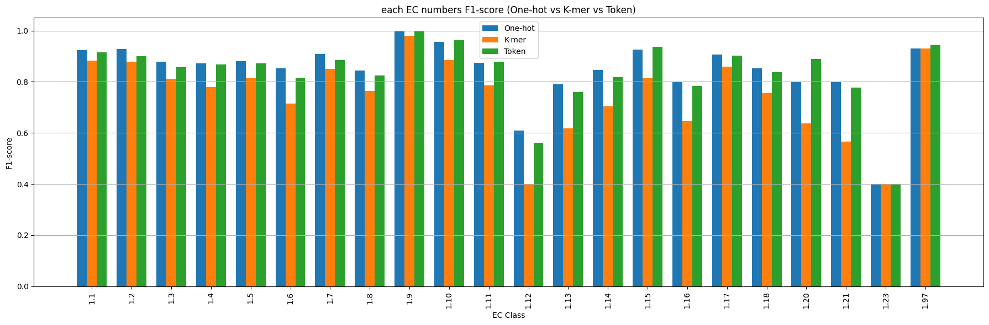
 | 1.1 | 1.2 | 1.3 | 1.4 | 1.5 | 1.6 | 1.7 | 1.8 | 1.9 | 1.10 | 1.11
One-hot | 0.916 | 0.914 | 0.815 | 0.855 | 0.876 | 0.84 | 0.906 | 0.848 | 1 | 0.948 | 0.872
k-mer | 0.887 | 0.876 | 0.812 | 0.798 | 0.829 | 0.687 | 0.822 | 0.751 | 0.978 | 0.855 | 0.784
Tokenization | 0.901 | 0.920 | 0.856 | 0.861 | 0.875 | 0.807 | 0.865 | 0.821 | 1 | 0.955 | 0.847
 | 1.12 | 1.13 | 1.14 | 1.15 | 1.16 | 1.17 | 1.18 | 1.20 | 1.21 | 1.23 | 1.97
One-hot | 0.608 | 0.818 | 0.826 | 0.941 | 0.776 | 0.907 | 0.85 | 0.8 | 0.8 | 0.4 | 0.924
k-mer | 0.476 | 0.673 | 0.688 | 0.797 | 0.586 | 0.854 | 0.789 | 0.636 | 0.565 | 0.4 | 0.929
Tokenization | 0.615 | 0.8 | 0.826 | 0.920 | 0.757 | 0.903 | 0.862 | 0.695 | 0.777 | 0.4 | 0.929

(3) Transformer Model Performance Metrics by EC Class
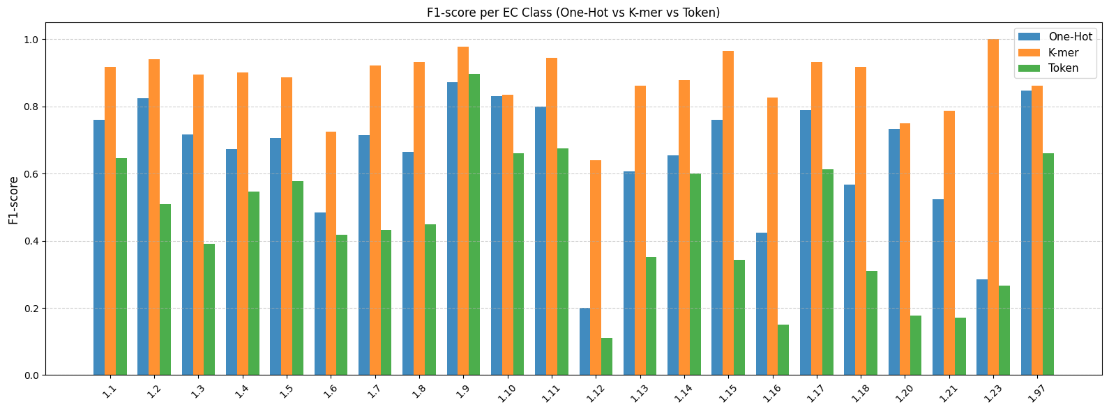
 | 1.1 | 1.2 | 1.3 | 1.4 | 1.5 | 1.6 | 1.7 | 1.8 | 1.9 | 1.10 | 1.11
One-hot | 0.761 | 0.823 | 0.715 | 0.672 | 0.707 | 0.483 | 0.715 | 0.664 | 0.872 | 0.831 | 0.566
k-mer | 0.918 | 0.94 | 0.894 | 0.902 | 0.885 | 0.725 | 0.922 | 0.931 | 0.978 | 0.835 | 0.945
Tokenization | 0.645 | 0.509 | 0.391 | 0.546 | 0.578 | 0.418 | 0.432 | 0.449 | 0.896 | 0.66 | 0.676
 | 1.12 | 1.13 | 1.14 | 1.15 | 1.16 | 1.17 | 1.18 | 1.20 | 1.21 | 1.23 | 1.97
One-hot | 0.799 | 0.2 | 0.606 | 0.654 | 0.761 | 0.423 | 0.790 | 0.733 | 0.524 | 0.285 | 0.847
k-mer | 0.64 | 0.862 | 0.878 | 0.964 | 0.827 | 0.931 | 0.917 | 0.75 | 0.787 | 1 | 0.861
Tokenization | 0.111 | 0.35 | 0.6 | 0.344 | 0.149 | 0.612 | 0.309 | 0.177 | 0.171 | 0.266 | 0.659

(4) Confusion Matrix–Based Evaluation of CNN Model Performance
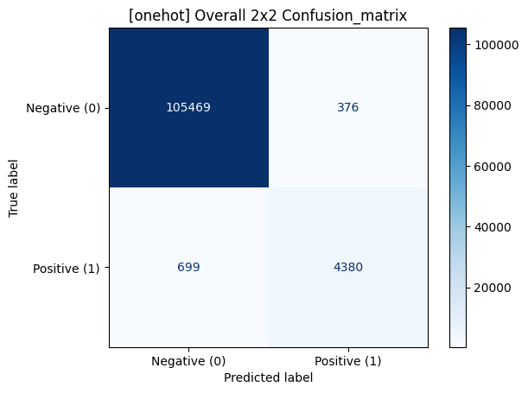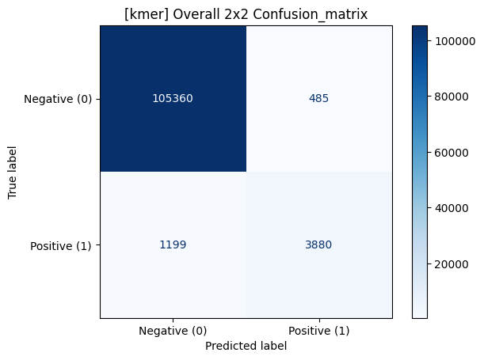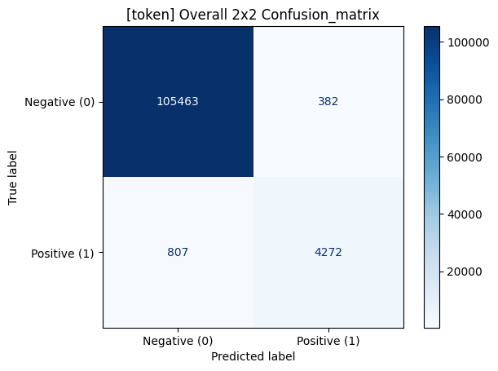

(5) Confusion Matrix–Based Evaluation of Transformer Model Performance
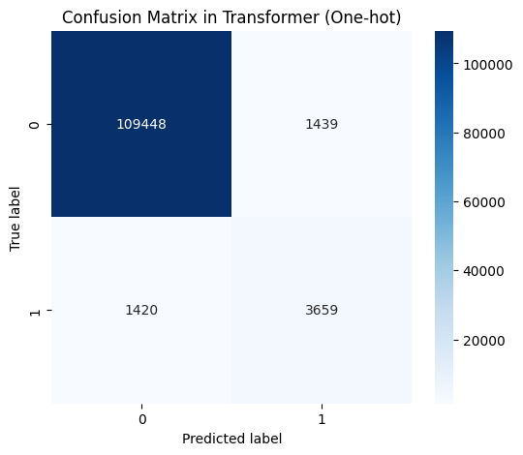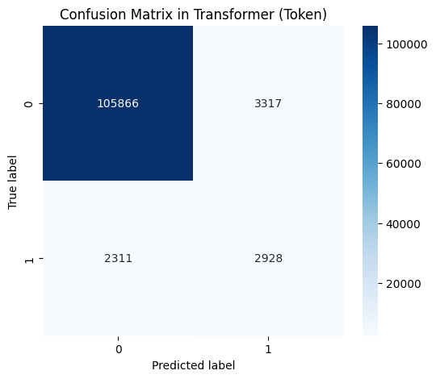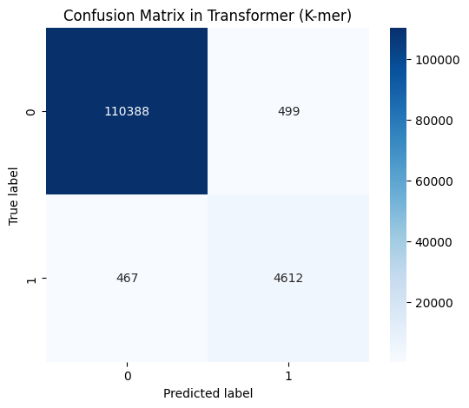
2. Interpretation of Results
(1) Experimental Results and Interpretation
In this study, we explored the prediction of enzyme function from amino acid sequences using two deep learning models: CNN and Transformer. We compared three encoding strategies—One-hot, K-mer, and Tokenization—to understand their impact on model performance. Evaluation was conducted using both Macro F1-score and Micro F1-score, which capture different aspects of classification performance.
(2) Overall Model Performance
CNN consistently outperformed the Transformer across all encoding types. When using One-hot encoding, CNN achieved a Macro F1-score of 0.8387 and a Micro F1-score of 0.8799, demonstrating robust and balanced performance across classes. In contrast, the Transformer showed more variable results, with a particularly sharp performance drop when using Tokenization (Macro: 0.4527), suggesting a high sensitivity to input sparsity and sequence representation.
(3) Impact of Encoding Strategies
Encoding methods significantly influenced model outcomes. For CNN, Tokenization outperformed K-mer and even surpassed One-hot encoding in certain classes, likely due to CNN's ability to extract meaningful local features from fixed-length token sequences. The Transformer, on the other hand, performed best with K-mer encoding, which appears to offer a more stable input representation for the attention mechanism. Performance with One-hot and Tokenization was lower, indicating that the Transformer struggled with representations that either lacked structural granularity (One-hot) or were too sparse (Tokenization).
(4) Class-Specific Performance Patterns
Final Report - Experimental result & Discussion 1 Certain EC classes displayed distinct patterns. Class 1.9 consistently achieved near-perfect scores across all encodings and both models, indicating that it is relatively easy to classify—possibly due to distinctive sequence patterns or sufficient training data. In contrast, classes such as 1.12, 1.13, 1.16, 1.20, and 1.21 consistently yielded lower F1-scores, suggesting that they are harder to distinguish, potentially due to limited samples or overlapping features with other classes.
(5) Interpretation of F1-Score Metrics
Macro F1-score evaluates each class equally, making it especially useful for assessing model performance across imbalanced datasets. CNN exhibited similar values for both Macro and Micro F1-scores, suggesting that it handled both frequent and infrequent classes well. In contrast, the Transformer showed lower Macro F1-scores in some cases, highlighting its difficulty in correctly classifying underrepresented classes.
(6) Performance Analysis of Sequence Encoding
Strategies in Enzyme Function Prediction To assess the influence of input encoding on enzyme function prediction, we evaluated Convolutional Neural Networks (CNNs) and Transformer models using three sequence representation methods: one-hot encoding, k-mer encoding, and tokenization. The evaluation was based on precision, recall, F1-score, and accuracy, derived from confusion matrix analysis.
CNN-Based Performance
For CNN models:
- One-hot encoding achieved the highest overall performance, yielding the best F1-score (89.00%) and accuracy (99.03%), demonstrating a well-balanced trade-off between precision and recall.
- Tokenization also delivered competitive performance with high precision (91.79%) and moderate recall (84.08%), resulting in a strong F1-score (87.87%).
- K-mer encoding showed the lowest recall (76.39%) among the three, indicating a higher rate of false negatives, although precision remained Final Report - Experimental result & Discussion 2 relatively high (88.89%). The overall accuracy (98.48%) does not fully capture this shortfall, suggesting a potential class imbalance effect.
Transformer-Based Performance
For Transformer models:
- K-mer encoding outperformed all other encoding methods, achieving the highest F1-score (90.49%) and accuracy (99.21%), with balanced precision (90.23%) and recall (90.79%). These results indicate that k-mer sequences are highly compatible with Transformer architectures.
- One-hot encoding yielded moderate performance, with balanced but lower precision and recall (both ~72%), leading to an F1-score of 71.92%.
- Tokenization, in contrast, resulted in significantly degraded performance, with a notably low precision (46.87%) and recall (55.89%). Despite an accuracy of 95.08%, this is likely an artifact of class imbalance and does not reflect true model efficacy.
(7) The Impact of K-mer-Based Input on Deep Learning Models
1. Capturing Local Sequence Patterns
K-mer encoding (k = 3) segments amino acid sequences into overlapping trigrams, enabling the capture of local sequence motifs that often correspond to functional or catalytic regions.
- In CNNs, such localized features align well with convolutional filters, allowing effective pattern recognition.
- In Transformers, k-mers offer denser and semantically meaningful tokens that leverage positional encoding and self-attention mechanisms, improving contextual representation.
2. Information Compression and Redundancy Reduction
Encoding sequences as individual amino acids (k = 1) leads to sparse, elongated inputs with low information density. This becomes computationally expensive, especially for Transformers, which scale quadratically with sequence length. Final Report - Experimental result & Discussion 3 K-mer encoding reduces sequence length substantially while preserving key functional signals, thereby enhancing both computational efficiency and learning performance.
(8) Incorporating EC Number Similarity into Loss Function Design
To further align model predictions with biological relevance, we designed a custom loss function that incorporates functional similarity between Enzyme Commission (EC) numbers.
- Predictions that differ slightly from the ground truth (e.g., at the fourth EC digit) incur a lower penalty.
- Predictions from unrelated classes (e.g., differing from the first EC digit) are penalized more heavily.
This hierarchical loss formulation encourages the model to make functionally similar predictions even when exact classification is uncertain, thus promoting biologically meaningful learning and generalization.
Discussion
Despite the use of GPU acceleration, the computational cost of training both CNN and Transformer models remains substantial. This is particularly evident in Transformer architectures, where input length significantly impacts memory usage and training time due to their quadratic complexity with respect to
sequence length.
Moreover, performance at the EC number level appears to vary depending on sequence length and data availability. EC classes with shorter sequences or limited training examples tend to exhibit lower predictive accuracy, highlighting the importance of data quantity and quality in deep learning-based enzyme classification tasks.
Lastly, both CNN and Transformer models demonstrate inconsistent performance across specific EC classes, indicating that the current training-validation setup may not adequately capture the full distribution of functional diversity. To mitigate this issue, implementing K-fold cross-validation could provide a more robust evaluation framework, potentially improving generalization and stability across underrepresented enzyme classes.
References
- Lord, P. W., Stevens, R. D., Brass, A., & Goble, C. A. (2003). Investigating semantic similarity measures across the Gene Ontology: the relationship between sequence and annotation. Bioinformatics https://pmc.ncbi.nlm.nih.gov/articles/PMC2709532/
- datax-lab. (2023). ECPICK: Biologically interpretable deep learning enhances trustworthy enzyme commission number prediction and discovers potential motif sites [Source code]. GitHub. https://github.com/datax-lab/ECPICK
- Alexey Dosovitskiy, Lucas Beyer, Alexander Kolesnikov, Dirk Weissenborn, Xiaohua Zhai, Thomas Unterthiner, Mostafa Dehghani, Matthias Minderer, Georg Heigold, Sylvain Gelly, Jakob Uszkoreit, Neil Houlsby. (2021). An Image is Worth 16x16 Words: Transformers for Image Recognition at Scale. International Conference on Learning Representations. https://arxiv.org/abs/2010.11929
- Yanrong Ji, Zhihan Zhou, Han Liu, Ramana V Davuluri, (2021) DNABERT: pre-trained Bidirectional Encoder Representations from Transformers model for DNA-language in genome https://doi.org/10.1093/bioinformatics/btab083
- Ashish Vaswani, Noam Shazeer, Niki Parmar, Jakob Uszkoreit, Llion Jones, Aidan N. Gomez, Lukasz Kaiser, Illia Polosukhin. Attention Is All You Need (2017) https://arxiv.org/abs/1706.03762
My contribution (Pyeonghwa Jang)
(1) Analysis of One-Hot Encoding
I thoroughly analyzed the code structure for one-hot encoding presented in the ECPICK paper, grasping its core concepts and implementation principles.
Based on this analysis, I designed the input vector generation and data preprocessing for one-hot encoding to fit the requirements and goals of our project. also, I shared these methods with my team.
(2) Design and Implementation of a Unified 1D CNN Architecture
I designed a 1D CNN architecture capable of handling diverse input types—including tokenization, k-mer, and one-hot encoding—within a consistent framework.
For each encoding method, I clearly separated the embedding and dimension transformation processes and implemented the neural network to reflect these flows transparently.
I optimized the composition of convolutional layers within the CNN to enable efficient learning of local sequence patterns.
(3) Experimental Design and Result Interpretation
I played in designing experiments to compare and analyze the practical impact and limitations of each encoding method using the 1D CNN architecture.
Based on the results, I communicated the insight that one-hot encoding structurally matches best with CNN and yields superior performance and discussed the strengths and weaknesses of token/embedding and k-mer approaches with the team.
I actively contributed to summarizing the findings and insights for reports and presentations.
(4) Assessment of Architectural Strengths and Limitations
Strengths:
- Unified 1D CNN structure for all encoding methods, ensuring consistent and scalable experimental comparisons.
- Optimized for local pattern learning, and able to learn directly from one-hot encoded data without information loss.
- Simple architecture, making interpretation and comparative analysis straightforward.
Limitations:
- Some structural features inherent to k-mer and token embeddings may not be fully leveraged.
These contributions contributed to form the project's encoding strategy and neural network architecture through deep one-hot encoding implementation and analysis, integrated 1D CNN design, visualization, experimental comparison, and result interpretation.

